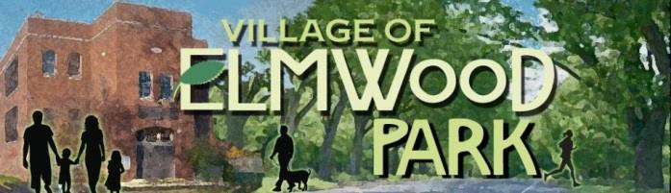
PLAN COMMISSION MEETING MINUTES
3131 Taylor Avenue, Bldg. 3, Racine, WI 53405
May 14, 2015 6:00 pm
All agenda items shall follow protocol including staff overview, Board discussion, questions by public, Board disposition of item. The public must be recognized by the President.

The meeting called to order at 6:12 p.m. by Village President Steiner. Present were Pete Clouthier, Al Bagg, Ellis Steiner, Leif Peterson, Mike Burks, and Clerk-Treasurer Tammy Ruggaber

The Village President leads the Village Board and audience in a prayer and then the pledge of allegiance.

PUBLIC COMMENT AND INPUT
Pursuant to Wisconsin Statute 19.84(2) "the public notice of a meeting of the governmental body may provide for a period of public comment, during which the body may receive information from members of the public."

Tom Mills, of 3274 N. Elmwood Drive, states he observed that the Kohl’s property is being worked on and wonders if the amount of permit fees is public record. President Steiner states that we have received approximately $4500 in fees.

Sheri Klabo, 3438 Elm Tree Court, asks if we will be talking about the audit from the prior evening. President Steiner said yes, briefly. She states she received an email about a prior meeting and it didn’t state the time. She requests that, in the future, we put the time in the heading of the announcements.

President Steiner states that there is a need to review and approve the Filling of Lands Ordinances (8.15) and Erosion Control (8.16). There is an issue outstanding with the Filling of Lands Ordinance (8.15) sub-section b states when a party desires to deposit fill in any amount, except any fill used for top soil dressing, in any lands in the village, such party shall first obtain a fill permit from the building inspector. The proposed ordinance defines top soil dressing as hand application of top soil to existing turf. President Steiner states we do not want to prohibit land owners from using a lawn tractor on their property.

The Commission, with input from Trustee Klimek and Pat Tierney, discuss how the sub-section needs to be amended. Leif Peterson makes a motion to table it, seconded by President Steiner, and the motion passes unanimously.

The Commission reviews the minutes from April 6th. Commissioner Burks states he is referred to as Trustee and asks it to be corrected. Leif Peterson moves the minutes be approved with that correction. Commissioner Bagg seconds, and it passes unanimously.

There is an application for a fence at 3628 Elmwood Drive. Commissioner Steiner states that there are two different types of fences with the application and he wonders if the applicants expect the Commission to choose a fence for them. The Commissioners discuss that the ordinances state the fence can be 4’ but if there is a pool then the fence may be 6’. President Steiner asks the clerk to send a letter to the Madsens asking them to appear at the next Planning Committee meeting to review their plan. President Steiner makes a motion to table the issue, seconded by Commissioner Peterson, and it passes unanimously.

President Steiner states Pat Tierney served 16 years on the Plan Commission and he thanks him for his service and there is a round of applause. Pat states he is happy to continue to assist in any way he can. President Steiner states we will handle the other part of the recognition at another meeting.

President Steiner states that Eric Fanning will be filling Pat Tierney’s position on the Plan Commission.

Commissioner Peterson addresses the issues of the fence on Standish Lane that exceeds height requirements and also that a letter needs to be sent to the owners of the willow tree. (Willow trees are prohibited by ordinance.) The home owner needs to either cut it down or appear for an appeal. Trustee Klimek states there are other properties that have decorative willows and he thought that they were going to be issued variances. Commissioner Peterson states that the Commission reviewed the ordinance and decided not to change it. Trustee Klimek will provide the Clerk with the addresses of other willow tree owners so she can send those home owners letters as well.

Commissioner Peterson brings up the berm by the Cell Tower.

Commissioner Steiner moves we adjourn. Commissioner Bagg seconds and the motion passes unanimously.

